Column Name: | Sort Order:
Start Time: | End Time: | Appointments Available for Scheduling:
  - BFC | - BI | - CERT
  - F/U | - FM | - FPC
  - HGB | - HR F/U | - MIDCERT
  - N/ED | - OST | - OTHER
  - PCERT | - RECERT

Column Name: | Sort Order:
Start Time: | End Time: | Appointments Available for Scheduling:
  - BFC | - BI | - CERT
  - F/U | - FM | - FPC
  - HGB | - HR F/U | - MIDCERT
  - N/ED | - OST | - OTHER
  - PCERT | - RECERT

Column Name: | Sort Order:
Start Time: | End Time: | Appointments Available for Scheduling:
  - BFC | - BI | - CERT
  - F/U | - FM | - FPC
  - HGB | - HR F/U | - MIDCERT
  - N/ED | - OST | - OTHER
  - PCERT | - RECERT

See example on the next page, don’t forget:
- Appointments Available for Scheduling- include any appointment type staff can schedule within this column (see I-WIC: Appointments guidance)
If an appointment type is not selected here, it will not be available to be schedule in the system
- Sort Order- is the order in which the columns will appear on the schedule (1 will appear on the far left and be the 1st column)
- Clinic closures/breaks- multiple rows can be added for a column, to avoid scheduling during times the clinic is closed
- Walk-In column- is required and must be entered into the system as: Walk-In (no breaks are needed in the Walk-In column)
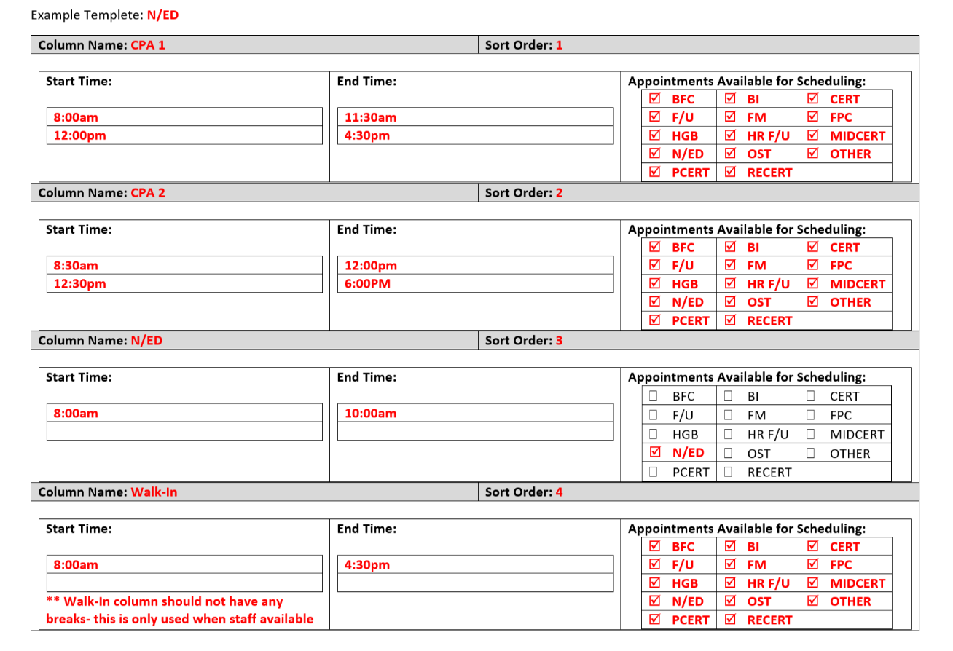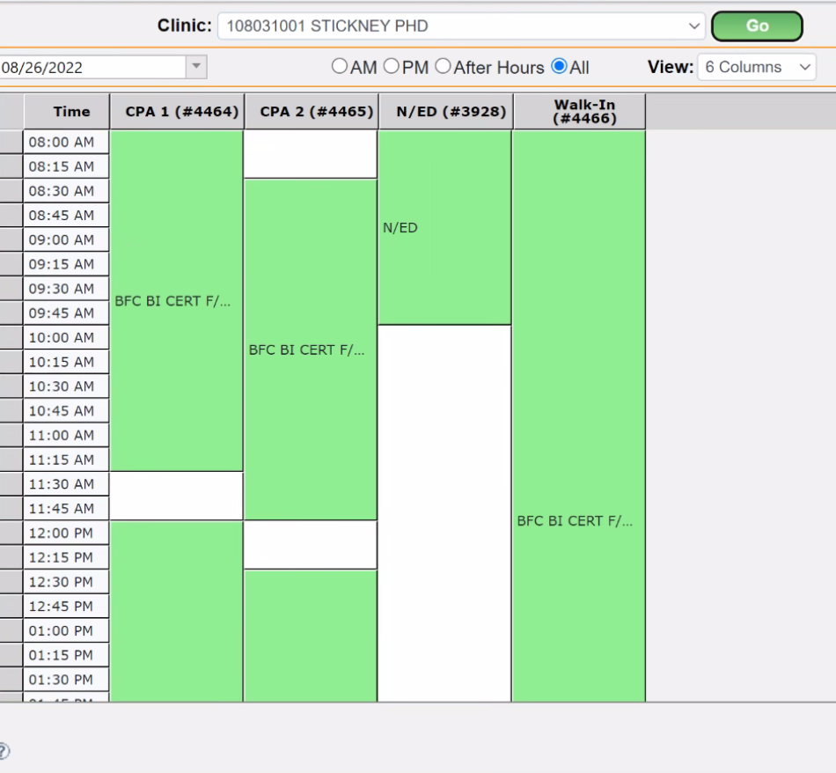
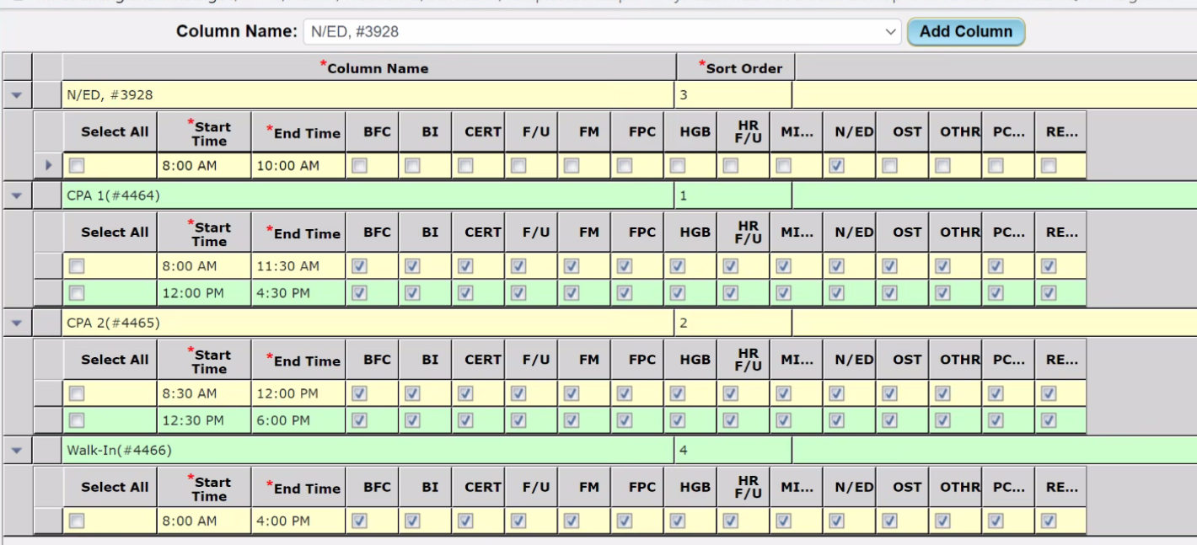
Notes:
_____________________________________________________________________________________________________________________________________________________________________________________________________________________________________________________________________________________________________________________________________________________________________________________________________________________________________________________________________________________________________________________________________

