Healthy and Proper Parenting for Youth breastfeeding Curriculum

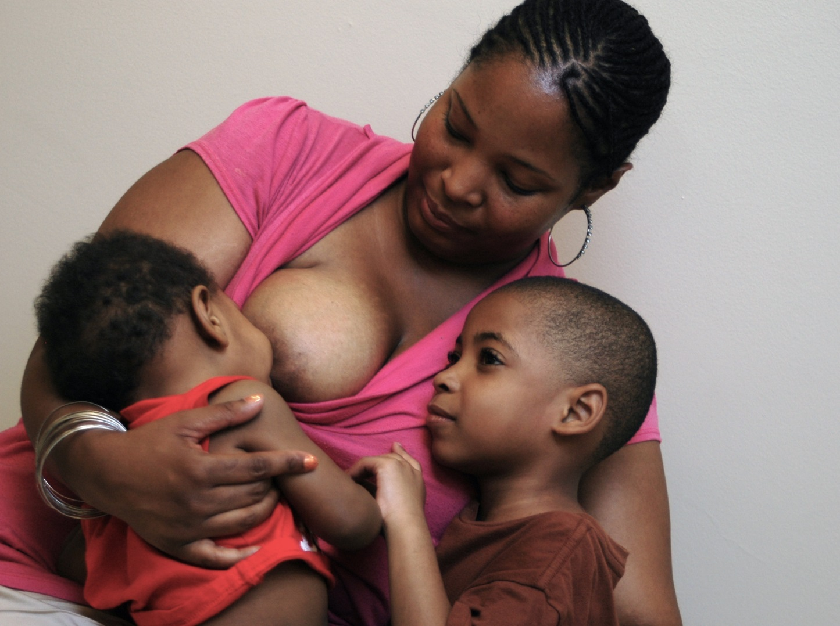
  - Collaboration with the GOALS project and the University of Illinois, Urbana-Champaign

Table of Contents
Workshop 1: SMART Goals Matters (1 hour) 4
Activity 1: What are SMART Goals? 6
Facilitator Guide: SMART Goals Guide Sheet 7
What are SMART Goals? 8
Activity 2: Practice your SMART goal 9
Worksheet: Practice your SMART goal 10
Activity 3: Storytelling through Scrapbooking 11
Directions: Storytelling through Scrapbooking 12-13
Homework: Revise your own SMART Goals 15
Workshop 2: Breastfeeding Matters (1 hour) 16
Activity 1: Video 1: “In Her Own Words” 18
Benefits of Breastfeeding 19
How do I know that my baby is getting enough milk? 20
Breastfeeding WIC Lego Chart 22
Activity 2: Video 2: “Teach Me How to Breastfeed” 23
Activity 3: Latch the Balloon 24
Signs of a Good Latch 26
Breastfeeding Matters Pamphlet 27-28
Workshop 3: You Matter (1 hour) 29
Activity 1: Breastfeeding Review 31
Activity 2: What color is your personality? 32
Hartman Color Personality Test Answers 35
Activity 3: Dealing with Stress 37
Worksheet: Dealing with Stress 38
Dealing with Stress Answers 39
Self-care Information 40
Activity 4: Body Stretches 43
Standing Stretches 44

About the Curriculum
This curricula consists of three 1-hour workshops that focus on making goals, breastfeeding and the importance of self-awareness and self-care. The curricula was designed for a group of African American, adolescent mothers and their mentors.
Purpose
The purpose of this curriculum is to increase pregnant and postpartum mothers’ knowledge about breastfeeding.
How to use this curriculum
Any part of the curricula should be revised that will best meet the needs of the population you are working with.
Facilitators
Facilitators can be anyone who has experience working with African American, adolescent mothers. For the Breastfeeding Matters workshop, it is preferable that facilitators have some knowledge of breastfeeding either through the Certified Lactation Counselor training or from personal experience. There are many misconceptions related to breastfeeding and therefore, some evidence-based breastfeeding information is provided on page 21.
Contact
Questions and comments about this curriculum can be sent to Julia Kim at haijikim@gmail.com.

Workshop 1
SMART Goals Matter

Workshop 1: SMART* Goals Matter
Total Time
1 hour
Objectives
At the end of this session, participants will be able to write out goals that are specific, measureable, action-oriented, realistic and timely.
Instructor Guide
- Before each workshop, become familiar with materials for the lesson plan.
- If possible, practice with several people before the workshop.
- Prepare and gather materials needed for all activities.
Activities
- Description of SMART goals (5 minutes)
- Practice your SMART goal! (10 minutes)
- Storytelling with scrapbooking (45 minutes)
Items needed for each activity
- Description of SMART goals
  - “What are SMART goals?” worksheet (page 8) – 1 per person
- Practice your SMART goal!
  - “My SMART Goal” worksheet (page 10)– 1 per person
  - Pens or pencils
- Storytelling with Scrapbooking
  - Scrapbooking materials (e.g., regular and patterned scissors, glue, tape, pictures, decorative paper, letter stickers, decorative stickers, rulers, paper cutters, markers, pens, glitter, glue, etc.)
  - Pictures
  - Scrapbooking and Storytelling directions page (pages 12 and 13) – 1 per person
- Homework
  - “Revise your own SMART goals” worksheet (page 15) – 1 per person
Concluding Remarks
Remind mothers to do their homework – revising SMART goals for themselves (page 15).
*Specific, Measureable, Action-oriented, Realistic, Timely

Activity 1: What are SMART Goals?
Total Time
5 minutes
Objective
Describe the SMART goals to mothers. At the end of this activity, mothers will understand what SMART goals stand for and how to write a SMART goal.
Materials
- “What are SMART goals?” sheet (page 8) – 1 sheet per person
Directions for Instructors
- Give each person a “What are SMART goals?” worksheet (page 8).
- Explain each of the SMART acronym and give an example of each using the next page.

SMART Goals Guide Sheet for Facilitators
The purpose of this guide sheet is to familiarize the instructor with SMART goals. It is highly recommended to write your own SMART goals for practice.
Emphasize that setting SMART goals is a great way to practice what it feels like to have self-control over your future.
SMART is an acronym that stands for Specific, Measureable, Action, Realistic, and Timely. It is used to set goals that map out exactly what you need to do.
- S – stands for Specific - The goal should identify a specific action or event that will take place. Ask yourself why you are creating this goal, who is involved in the goal, and how will you reach that goal.
    - Not specific - I will get good grades.
    - Specific - I will get a 93 in my math class by the end of the semester.
- M – stands for Measurable - The goal and its benefits should be quantifiable. Ask yourself “How will I know when it is accomplished?”
    - Not measurable - Find and apply to job openings.
    - Measurable - Find and apply to five job openings.
- A – stands for Action - Your goal should be action-oriented.
- Not action-oriented – I will get good grades.
- Action-oriented – I will study for 20 minutes every night to get a 95 in math class.
- R – stands for Realistic – Can you achieve these goals? Is it doable?
- Unrealistic - I will apply to 50 job openings in 1 week.
- Realistic – I will apply to five to ten job openings in 1 week.
- T – stands for Timely – You should set a timeframe for your goal.
- Not timely – I want to learn to play the piano.
- Timely – I want to learn to play the “ABC’s” in 1 month.
Tips
- Make about 3 to 5 goals. This gives you several things to work on over a period of time. If you think you can handle more goals, make more. If not, focus on one main goal.
- Write out your goals and put it somewhere you will see it easily and regularly.
- Review and revise your goals whenever you need to.
Discussion Question (optional)
- Who has heard of the SMART goals?
- How does writing SMART goals help reach your goal?
- What SMART goals did you come up with?

What are SMART Goals?
Specific: Your goal should identify a specific action or event that will take place.
For example, “find and apply for job openings” is better than “find a job”.
Realistic: Your goal should require you to stretch some, but allow the likelihood of success.
Action-oriented: Your goal should have action verbs that you will do to reach your goal.

Measurable: Your goal and its benefits should be quantifiable.
For example, “apply to 5 job openings” is better than “apply to jobs”.
Timely: Your goal should state the time period in which it will be accomplished.
For example, try “find and apply for five job openings by the end of this month”.

Activity 2: Practice your SMART goal!
Total Time
10 minutes
Objective
At the end of this activity, mothers will have written one SMART goal that they want to achieve.
Materials
- “Practice your SMART goal” activity sheet (page 10) – 1 or more per person
Directions for Instructors
- Give each student one or more copies of “Practice your SMART goal” worksheet.
- Mothers must answer each question to write a SMART goal.
Tips
- Having more than one copy allows the person to freely make mistakes their first time.

Practice your SMART goal
Directions: Make changes to your goal by answering each question.
What is your goal?
________________________________________________________________________________
Specific: What exactly will you accomplish?
________________________________________________________________________________________________________________________________________________________________
Measurable: Is your goal measurable? If not, how can you make your goal measurable?
________________________________________________________________________________________________________________________________________________________________
Action-oriented: What will you do to reach your goal? Write two actions that you will do to reach your goal. Use action verbs such as “read”, “study”, etc.
________________________________________________________________________________________________________________________________________________________________________________________________________________________________________________________________________________________________________________________________
Realistic: Can you achieve this goal? Is it doable? If not, how can you make your goal realistic? ________________________________________________________________________________________________________________________________________________________________
Timely: When will you achieve this goal?
________________________________________________________________________________________________________________________________________________________________
Combine your answers to the questions and write your new SMART goal:
________________________________________________________________________________
________________________________________________________________________________
________________________________________________________________________________

Activity 3: Storytelling through Scrapbooking
Total Time
45 minutes
Objective
At the end of this activity, mothers will have at least one scrapbook page that includes at least one SMART goal, 1 picture, and a letter or note.
Materials
- “Storytelling with Scrapbooking” directions page (page 12 and 13)
- Polaroid camera with photo paper (try to give each person at least 2 photos) or printed pictures
- Scrapbooking materials
  - Patterned and non-patterned scissors
  - Crayons, markers, colored pencils, glue sticks
  - Construction paper, decorative paper for scrapbooking
  - Stickers, letter stickers about motherhood, setting goals, motivation, etc.
  - Scrapbook album (You can also use plastic page covers or thick construction paper.)
  - Thank you cards, notepads, etc.
Directions for Instructors
- Give “Storytelling with Scrapbooking” directions page (page 12 and 13) – 1 per person
- Create a scrapbook page of a goal you want to achieve.
- Make sure to include one SMART goal, 1 picture, and a letter to either yourself or to someone who you are grateful for. (If you do not have a polaroid camera or printed photos, leave a space where mothers can place a picture once they reach their goals.)
- After about 40 minutes, we are going to ask you to share your story based on what you made on your scrapbook page.
Important points
- Writing your goals makes it more likely that you will achieve your goals.
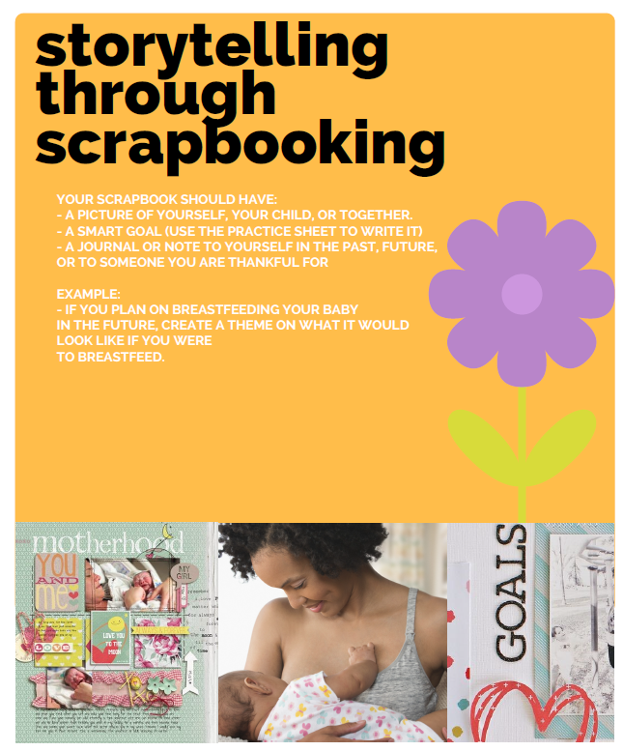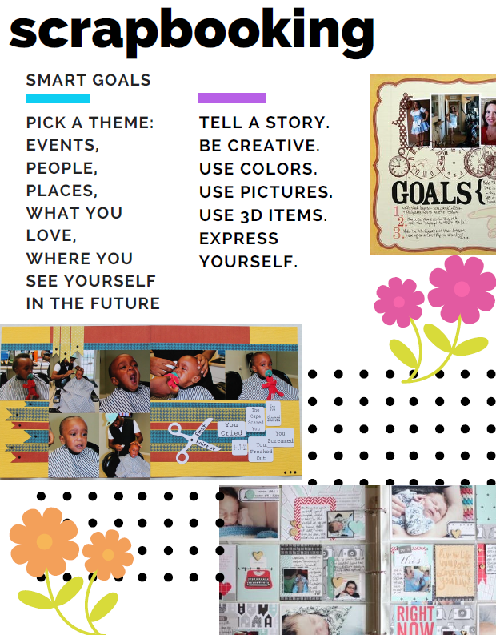

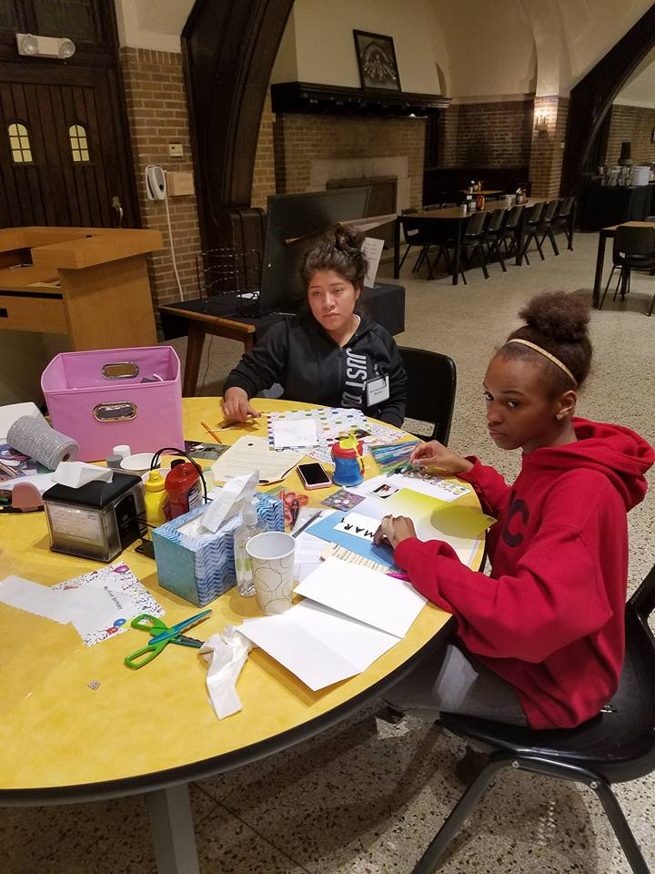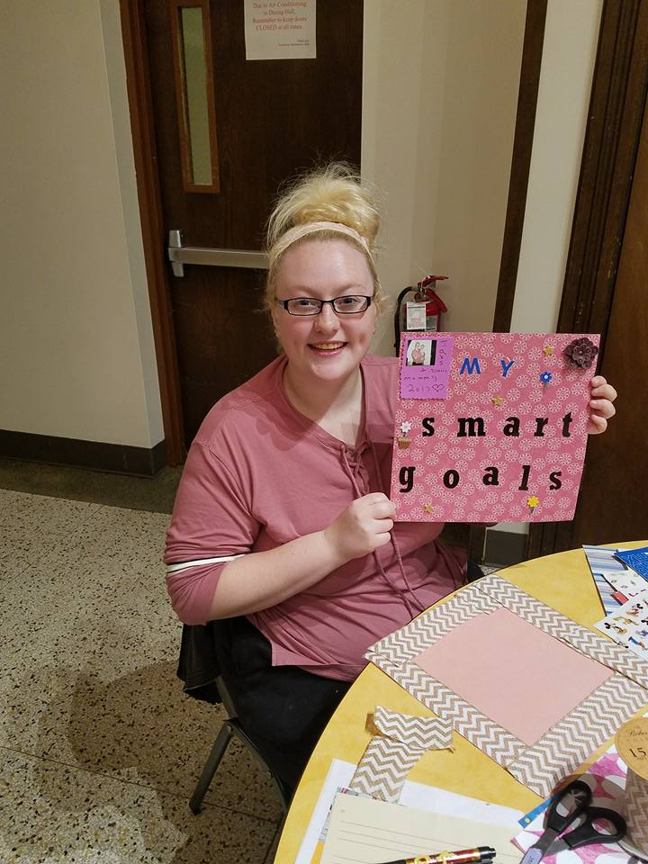

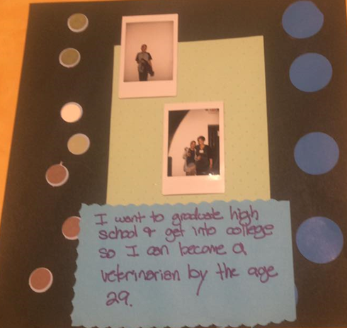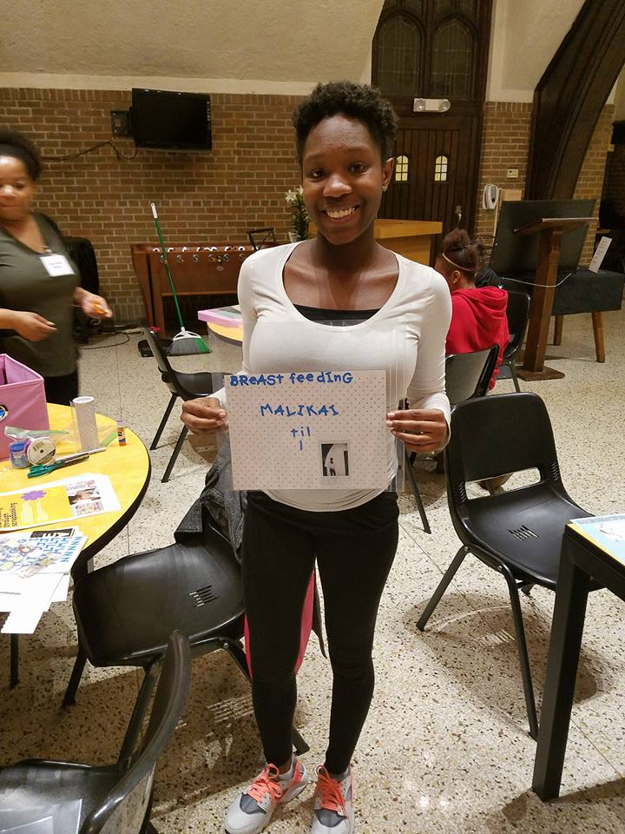

Homework: Revise your own SMART Goals
Directions: Make changes to your goals by following the SMART goals guidelines. Two of your goals should be short-term (within 12 months) and two should be long-term (longer than 12 months).
Goal #1: ________________________________________________________________________________________________________________________________________________________________
Revised SMART Goal #1:
________________________________________________________________________________________________________________________________________________________________
Goal #2: ________________________________________________________________________________________________________________________________________________________________
Revised SMART Goal #2:
________________________________________________________________________________________________________________________________________________________________
Goal #3: ________________________________________________________________________________________________________________________________________________________________
Revised SMART Goal #3:
________________________________________________________________________________________________________________________________________________________________
Goal #4: ________________________________________________________________________________________________________________________________________________________________
Revised SMART Goal #4:
________________________________________________________________________________________________________________________________________________________________

Workshop 2
Breastfeeding Matters

Workshop 2: Breastfeeding Matters
Total Time
1 hour
Objectives
At the end of this lesson, mothers will be able to identify one benefit of breastfeeding, one way to solve a breastfeeding problem, and explain how to latch a baby.
Instructor Guide
- Before each workshop, become familiar with materials and activities.
- If possible, practice with several people before the workshop and modify the lesson based on others’ feedback.
- Prepare and gather materials needed for all activities.
Activities
- Video 1: “In Her Own Words” (25 minutes)
- Video 2: “Teach Me How to Breastfeed” (25 minutes)
- Latch the Balloon (10 minutes)
Materials needed for each activity
- Video 1: “In Her Own Words” (https://www.youtube.com/watch?v=xxgZC2ktfOY)
  - Projector or TV to show videos
  - Breastfeeding WIC Lego chart (page 22)
- Video 2: “Teach Me How to Breastfeed” (https://www.youtube.com/watch?v=SZ3QO-7h4YA&list=PLxMBeI3FJh4vMhad9hKNPmsuTkeHyEmeq)
- Projector or TV to show videos
- Latch the Balloon
- Inflated balloons (2 per person) – preferably white or a light color so that one can see the lipstick stain
- Lipstick (1 per person) – preferably not matte because it dries too quickly
- Mirror (1 per person) – optional
- “Signs of Good Latch” sheet (page 25)
Tip
It is recommended that the mothers lead the workshops by allowing them to ask questions.
Conclusion
Give gift bags to each person (suggestions: Freezable Lunch bag to store breast milk at work; breast pump attachments; nursing scarf; baby wipes; diapers; pump wipes)

Activity 1: Video 1 – “In Her Own Words”
Total Time
20 minutes
Objective
At the end of this activity, participants will be able to name two benefits of breastfeeding.
Preparation
- Persons leading this workshop should be knowledgeable about breastfeeding and preferably have had breastfeeding experience.
Materials
- Projector or TV to show videos (I used a laptop and projector.)
Directions for Instructors
- Play “In Her Own Words” YouTube video: https://www.youtube.com/watch?v=xxgZC2ktfOY
- Ask discussion questions.
- Discuss the Breastfeeding WIC Lego chart (page 22)
Discussion Questions
- What are some main points of the video?
  - Family history of breastfeeding
  - Breastfeeding is healthy for the baby
  - Exclusively breastfeed (no water, Gatorade, cereal, cow’s milk) for the first six months.
- What are some benefits of breastfeeding that she pointed out?
  - Bonding
  - Free
  - Use breastfeeding as an excuse not to do something
  - Lower risk of infant mortality rate
  - Do not need to eat healthy to breastfeed
- What are some challenges to breastfeeding that she described?
  - Thrush
- What were some of the differences between her first and second baby?
  - First baby: Breastfeeding went well except engorgement
  - Second baby: Latched well but had thrush, which was painful.

Benefits of Breastfeeding
Main Point: Breastfeeding benefits both the mom and the baby. Feeding your baby ONLY breastmilk (no water, cereal, cow’s milk, etc.) for 6 months is recommended by the American Academy of Pediatrics. Human milk has all the nutrition that your baby needs for the first 6 months.
Benefits for Babies and Kids:
- Stronger Immune System – Babies who are breastfed have fewer infections and are less likely to get sick.
  - Fewer and less severe episodes of vomiting and diarrhea
  - Fewer respiratory infections (e.g., pneumonia, wheezing, cold)
  - Fewer ear infections
  - Fewer gastrointestinal infections
- Lower risk of Infant Death – Fewer babies die when breastfed (compared to formula-fed)
  - Less likely to get necrotizing enterocolitis in premature infants
  - Lower risk of SIDS (Sudden Infant Death Syndrome)
- Less chance of these:
  - Asthma
  - Obesity/Overweight
  - Eczema
- Higher IQ
Benefits for Moms:
- Lower risk of certain cancers
  - Breast cancer – The longer a woman breastfeeds, the more they are protected against breast cancer.
  - Ovarian cancer – Ovarian cancer is less likely if you breastfeed for 6 months or longer.
- Lower risk for:
  - Type 2 diabetes
  - Postpartum depression (this has been shown to be bidirectional – mothers who have postpartum depression are less likely to breastfeed.)
  - Cardiovascular disease
  - Obesity/Overweight
- Child spacing – “Lactational amenorrhea method” is a natural birth control technique. These three criteria must be met to ensure adequate protection from an unplanned pregnancy: (1) amenorrhea, (2) fully or nearly fully breastfeeding (no interval of >4-6 hours between breastfeeds), and (3) <6 months postpartum. (https://www.cdc.gov/reproductivehealth/contraception/mmwr/mec/appendixg.html)
Benefit for Mom and Baby:
- Bonding – Hormone that causes milk to come out (oxytocin) makes you want to care for your baby, makes you happy, makes you feel good when you are close to the baby.
*Based on Breast for Success. University Hospitals MacDonald Women’s Hospital. Available from www.uhhospitals.org/macdonald/health-and-wellness/pregnancyresources/lactation-services/breast-for-success

How do I know that my baby is getting enough milk?
- Number of feeds
You should feed your baby 8 to 12 times per day.

- Do you hear a swallow?
You should hear your baby swallow after a couple of sucks. After breastfeeding, you should see some milk in your baby’s mouth.
- Number of diapers

Rule of 4 – Your baby should have 4 soiled diapers per day by day 4, and everyday after.

- Weight
Your baby should gain 0.7 – 1 ounce (20-30 grams) per day after 1 week of age. (There are 16 ounces in 1 pound.) It is normal for your baby to lose 7% or less of his weight by day 5.

Problems | Solutions
Food & Nutrition | - Women breastfeed in third world countries and in conditions we can’t even imagine (like concentration camps).  - Undernourished mothers: Supplemented and unsupplemented mothers had babies that grew the same.  - Water or Fluid: Increasing water or fluid intake does not increase milk volume.  - Changing Diet: If your baby seems to have stomach problems after breastfeeding, it might be due to cow’s milk. It takes about 2 weeks for your body to get rid of cow’s milk protein. Talk to your doctor about it.
Breast Size: “It’s about breast size.” | - The number of glandular and fat tissue and number and size of ducts are not related to milk production.  - Law of supply and demand: You make more milk, the more you breastfeed or pump.  - Pregnancy causes droopy breasts.  - If you don’t breastfeed, you are going to have saggy breasts anyway. Gravity works on everyone.  - If you get help early, there is less chance that any changes will happen to your nipples.
Alcohol | - Fact: Alcohol does pass through milk and babies don’t like the taste.  - Fact: Alcohol is not trapped in milk (pumping and discarding it will not remove alcohol).  - Recommendation: You can breastfeed as long as you feel okay. If you feel tipsy or drunk, your milk is tipsy or drunk.
Cigarette | - Smoking mothers may make less milk and their full-term babies may gain weight less.  - Smoking mothers may have lower prolactin levels (which makes milk). After 12 hours of not smoking, the prolactin levels rise was more like the non-smokers.  - Breastfeeding may reverse the negative effects on the child’s cognitive development of smoking during pregnancy.
Cannabis | - Academy of Breastfeeding Medicine urges caution about the use of marijuana during breastfeeding.  - ABM: “At this time, although the data are not strong enough to recommend not breastfeeding with any marijuana use, we urge caution.”
Birth-Control Pills | < 1 month postpartum: Progestin-only pill, Injection and Implant  1 month or more postpartum: Combined hormonal contraceptive (pill, patch, ring), Progestin-only pill, Injection and Implant  (https://www.cdc.gov/reproductivehealth/unintendedpregnancy/pdf/legal_summary-chart_english_final_tag508.pdf)
Caffeine | - A mother’s caffeine habit does not relate to the amount of caffeine in her milk.  - However, caffeine may accumulate in premature and very newborn infants.  - Caffeine consumption during pregnancy and by nursing mothers has no consequences for infant sleep.  - Coffee consumption is not associated with duration of feeding only human milk.
Clingy | - Breastfeeding babies make babies feel secure. They have a better sense of security.  - There are other ways that your partner can bond with your baby:  - Skin to Skin with dad  - Changing diapers  - Pumping and then bottle-feeding  - Playing and sleeping with baby

Breastfeeding WIC Lego Chart
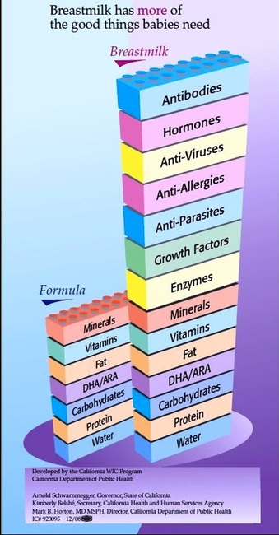

Activity 2: Video 2 – “Teach Me How to Breastfeed”
Total Time
20 minutes
Objective
At the end of this activity, mothers will be able to name two benefits of breastfeeding.
Preparation
- Facilitators leading this workshop should be knowledgeable about breastfeeding and preferably have had breastfeeding experience.
Materials:
- Computer and projector (or some other way to show videos)
Directions for Instructors:
- Play “Teach Me How to Breastfeed” YouTube video: https://www.youtube.com/watch?v=SZ3QO-7h4YA&list=PLxMBeI3FJh4vMhad9hKNPmsuTkeHyEmeq
- Ask discussion questions
Discussion Questions:
- What are some benefits of breastfeeding that she pointed out?
  - Size of breasts does not matter – mothers can have small breasts to make enough milk
  - Free
  - All my baby needs
  - Nose to nipple
  - It shouldn’t hurt if done correctly
  - Cross-cradle
  - Feed on demand
  - Vitamins and protection that only mom can give.
  - Liquid gold is perfect for a one day old
  - If poops are frequent and mustard yellow, you are doing well.
- What questions do you have about breastfeeding?

Activity 3: Latch the Balloon
Total time
10 minutes
Objective
At the end of this activity, mothers should be able to know how to latch a baby onto breasts.
Materials
- Signs of a good latch sheet (page 25) - 1 per person
- White balloons - 2 per person
- Lipstick (preferably not matte) - 1 per person
- Mirror (optional) - 1 per person
Directions for Instructors
- Give each person two balloons, a lipstick, and a mirror (optional).
- Tell the group to put on lipstick. Then open their mouths as big as possible and lift the balloon straight to your face. Put both lips on the balloon so that both (top and bottom) parts of your lips touch the balloon at the same time.
- Now, grab the second balloon. Put on more lipstick if you need to. Open your mouth as big as possible and lift the balloon to your chin.
- Let your bottom lip touch the balloon first, then your top lip.
- After they “latch” onto both balloons, ask “what differences do you see?” They should see that the second balloon has a bigger opening and that is how a baby should latch.
- Give out the “Signs of a good latch” handout and explain what a latch is. Latch is when your baby takes a big mouthful of your nipple and the areola (the circle around your nipples).
Discussion Questions
- What are the differences that you see in the two balloons?
  - Answer: The second balloon should have a bigger circle than the first balloon. To latch a baby, point the nipple to the nose (Nose to Nipple) and the bottom lip should touch the breast first, then the top lip. This will allow more of the nipple to enter the baby’s mouth.
- What are some reasons why your baby should latch onto your breasts well?
  - Answer: If your baby has a good latch, breastfeeding should not be painful.
- How do you know whether your baby has a good latch? (See “Signs of a Good Latch” page.)
  - Baby’s mouth is wide open.
  - Baby’s tongue is on top of his lower gum.
  - Baby’s lips are curled out.
  - Baby’s chin touches your breast.
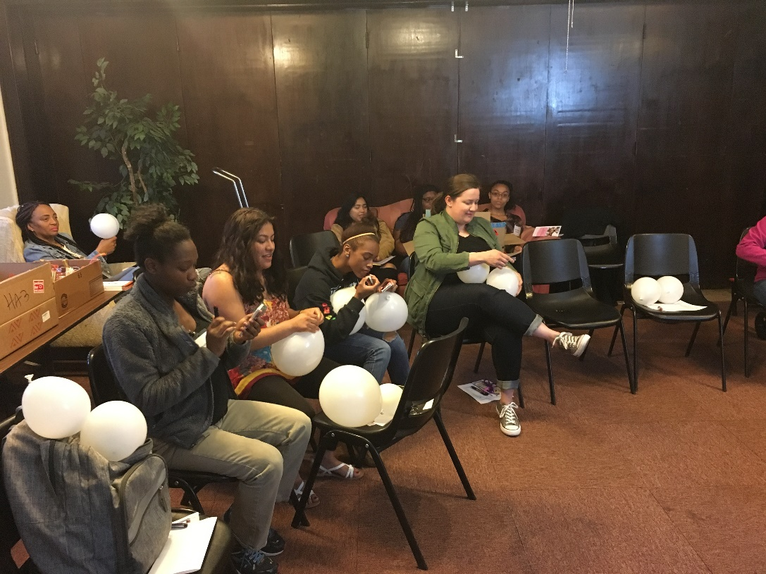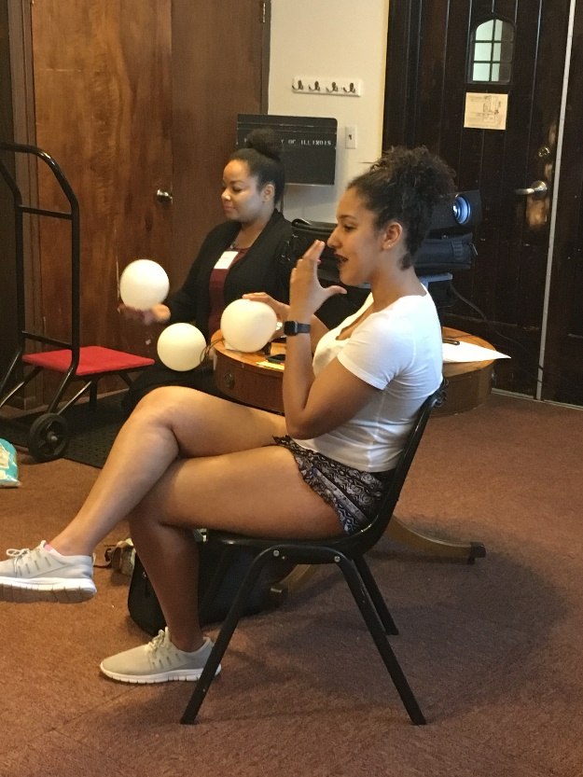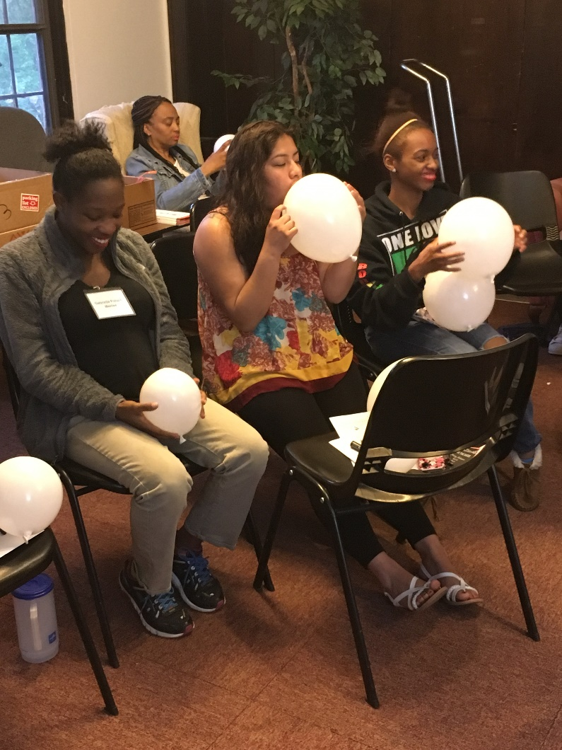

Signs of a Good Latch
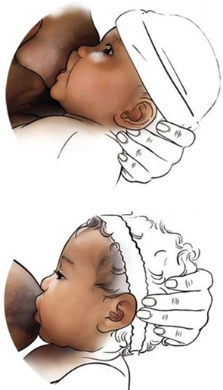
Poor Latch
Signs of a poor latch:
- Baby’s mouth is barely open.
- Baby’s tongue is behind the lower gum.
- Baby’s lips are curled in.
- Baby’s chin barely touches your breast.
Good Latch
Signs of a good latch:
- Baby’s mouth is opened wide, like a yawn.
- Baby’s tongue is over his lower gum.
- Baby’s lips are curled out, like a fish.
- Baby’s chin firmly touches your breast.

Breastfeeding Positions
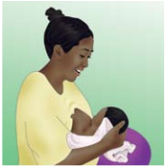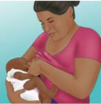
Cross-Cradle Hold:
Your right hand supports the back of neck and you feed from left breast (and vice versa).

Cradle Hold:
Your hand should be supporting your baby’s bottom. Your baby’s head is supported by your inner elbow.

Football Hold:
Rest the body on one arm then bring the doll to your right side and feed from your right breast.

Side-Lying Position:
Lay down on your side with your baby laying down in front of you.

**Based on the U.S. Department of Health and Human Services. Your Guide to Breastfeeding for African American Women. Available from https://www.womenshealth.gov/files/assets/docs/breastfeeding/breastfeedingguide-africanamerican-english.pdf

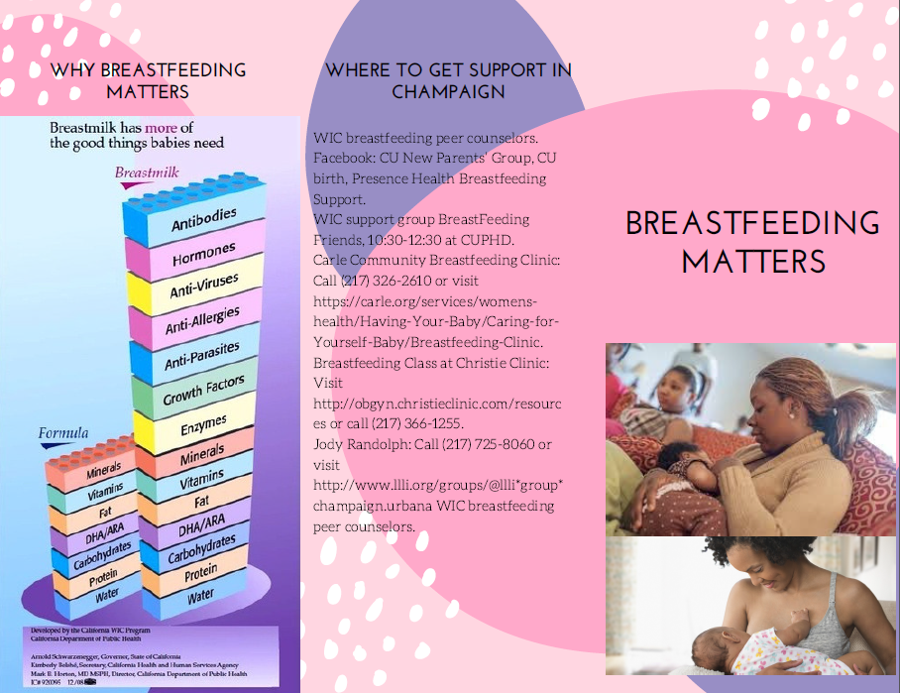
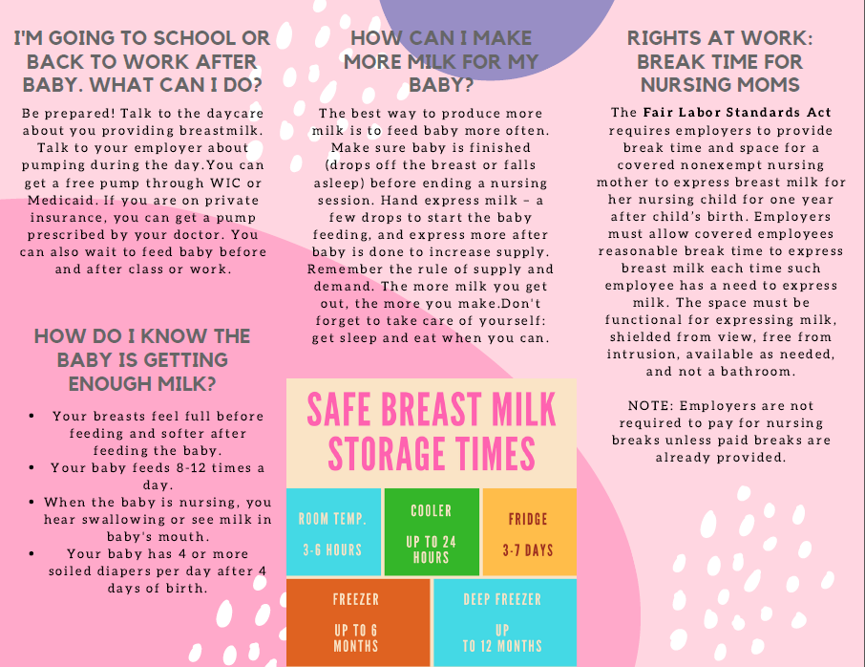

Workshop 3
You Matter

Workshop 3: You Matter
Total time
1 hour
Objective
By the end of this workshop, mothers will be able to identify traits that are essential to being a good mother, personal stressors, and ways to take care of themselves.
Instructor Guide
- Before each workshop, read the entire workshop and become familiar with materials for the lesson plan.
- If possible, practice with several people before the workshop.
- Prepare and gather materials needed for all activities.
Activities
- Breastfeeding Review (5 minutes)
- What color is your personality? (25 minutes)
- Dealing with Stress (15 minutes)
- Body Stretches (15 minutes)
Materials
- Personality cards (printed on 4 different colored papers with words/phrases individually cut-out) - see separate file called “Personality Card Printouts”
- “Dealing with Stress” worksheet (page 38) - 1 per group
- Hartman Personality Profile answer sheet (pages 35 and 36) - 1 per person

Activity 1: Breastfeeding Review
Total Time
5 minutes
Objective
By the end of this activity, participants will be familiar with breastfeeding benefits and myths.
Preparation
- Poster board with questions and answers to breastfeeding benefits and myths.
- (Optional)
Materials
- What are five breastfeeding benefits?
  - Bonding
  - Fewer infections for babies
  - Lower chance of breast and ovarian cancer for mothers
  - Higher IQ
  - Stronger immune system
- What are four breastfeeding myths?
  - I need big breasts to breastfeed. All mothers with various breast sizes can breastfeed.
  - I need to eat healthy to breastfeed. No matter what you eat, your breast milk will have all the nutrients that your baby needs.
  - I need to drink a lot of water while breastfeeding. You do not need to drink a lot of water while breastfeeding. You will still make more milk, as long as you continue breastfeeding.
  - I can’t smoke or drink while breastfeeding. Although it is not recommended to smoke or drink while breastfeeding, the benefits of breastfeeding while smoking is greater than formula-feeding.
Directions for Instructors
- Review the two questions (What are the five benefits of breastfeeding? What are four myths about breastfeeding?) by dividing the group into teams and asking them to write out their answers. The team with the most number of correct answers wins!
  - If you do not want to make this a game, simply ask the group to guess the benefits and myths about breastfeeding.
Tips
- To make this more interactive, create a poster board with folded paper, with the questions on the top of the folded paper and answers inside the folded paper.
Activity 2: What color is your personality?
Total Time
25 minutes
Objective
By the end of this activity, participants will learn more about themselves and their peers.
Preparation
- Print out “Red” personality trait cards on red/pink paper.
- Print out “Blue” personality trait cards on blue paper.
- Print out “Green” personality trait cards on green paper.
- Print out “Yellow” personality trait cards on yellow paper.
- Cut out each word/phrases.
Materials
- Adjectives or phrases cut-out individually and on different colors based on personality color
- Hartman Color Personality Test Answers (pages 35 and 36) - 1 per person
Directions for Instructors
- Place personality trait cards on tables (several tables might make it easier for bigger groups of people).
- Ask participants to pick out five words that best describes who they are and give five words to others.
- Once each person has a dominant color, reveal to them that the color represents one of the four personalities types.
- Group participants into their personality colors.
- Hand out the Hartman Personality Profile answer sheet. Review the different personality types.
Tips
- To make this more interactive, create a poster board that describes each personality or a PowerPoint presentation with a description of all of the personality types.
Discussion Questions
- Comparing the words you chose and words others gave you, which words were the same? Which words were different?
- How well do your personality traits describe you?
- How do your personality traits that you chose show up as a mother?
- Which personality color do you think needs the most “me” time? Why so?
  - Main Point: Everyone needs personal time but it depends on the person.

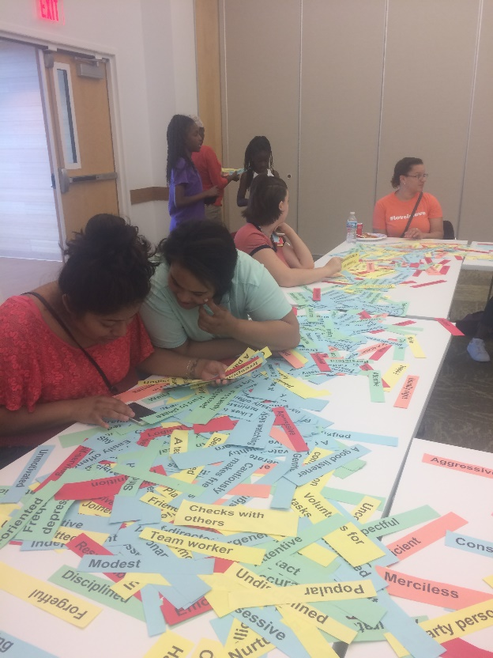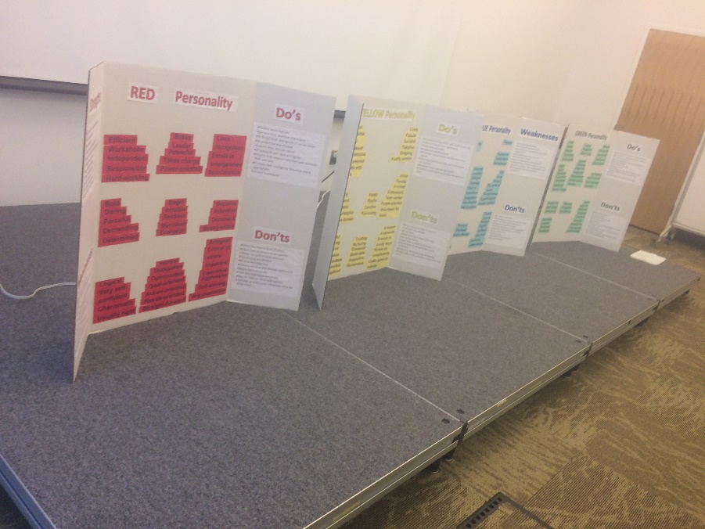

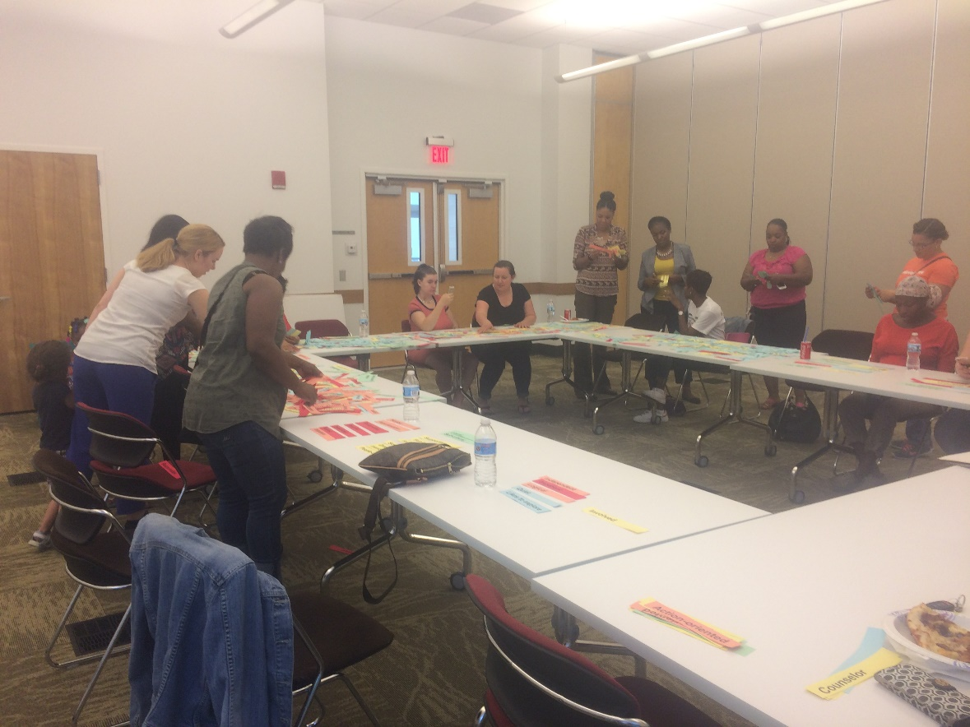

 | Red | Yellow | Blue | Green
1 | Self-confident | Trusting | Sensitive | Structured
2 | Spontaneous | Checks with others | Dreamer | Analytical
3 | Straightforward | Involved | Likes to explore | Organized
4 | Bossy | Rebellious | Easily offended | Stubborn
5 | Demanding | Nurturing | Quiet | Persistent
6 | Takes charge | Joiner | Likes to brainstorm | Resists change
7 | Energetic | Harmonious | Overgenerous | Cautious
8 | Outspoken | Caring/helpful | Mild-mannered | Consistent
9 | Forceful | Believable | Possessive | Disciplined
10 | Daring | Playful | Visionary | Dutiful
11 | Bold | Friendly | Satisfied | Logical
12 | Eager | Well-liked | Imaginative | Accurate
13 | Charismatic | Optimistic | Inventive | Reserved
14 | Powerful | Team worker | Independent | Traditional
15 | Restless | Talkative | Modest | Attentive
16 | Leader | Counselor | Designer | Controller
17 | Workaholic | Supportive | Self-directed | Exact
18 | Hard-working | Positive thinker | Imaginative | Detail-oriented
19 | Result-oriented | People-oriented | Idea-oriented | Task-oriented
20 | Likes recognition | Flexible/Adaptable | Emotional | Particular
21 | Irritable | Easily threatened | Easily offended | Rigid
22 | Frank/Candid | Indirect | Careful | Strict
23 | Goal-oriented | Volunteers for tasks | Capable | Schedule-oriented
24 | Excels in emergencies | Thrives on compliments | Dry sense of humor | Avoids causing attention
25 | Determined | Enthusiastic | Enjoys watching people | Sets very high standards
26 | Very self-confident | Dresses in trendy ways | Cautiously makes friends | Likes to be thorough
27 | Usually right | Looks good on outside | Avoids conflicts | Neat & Tidy
28 | Opinionated | Outgoing | Indecisive | Perfectionist
29 | Power-oriented | Self-centered | Tolerant | Sympathetic
30 | Dominant | Naïve | Indecisive | Loyal
31 | Decisive | Irresponsible | Tolerant | Suspicious
32 | Arrogant | Sociable | Unsure | Worry prone
33 | Self-serving | A teaser | Slightly stubborn | Reliable
34 | Assertive | Annoying | Kind | Self-critical
35 | Action-oriented | Carefree | Reluctant | Analytical
36 | Critical of others | A party person | Easy-going | Unforgiving
37 | Responsible | Happy | Shy | Moody
38 | Impatient | Impulsive | A good listener | Respectful
39 | Strong-willed | Fun-loving | Unmotivated | Unrealistic
40 | Argumentative | Forgetful | Considerate | Dependable
41 | Independent | Undisciplined | Passive | Frequently depressed
42 | Aggressive | Popular | Patient | Hard to please
43 | Insensitive | Uncommitted | Directionless | Thoughtful
44 | Logical | Spontaneous | Even-tempered | Sincere
45 | Efficient | A show-off | Hesitant | Guilt prone
46 | Merciless | Lively | Gentle | Well-behaved

Hartman Color Personality Test Answers
Red
Tasks and results oriented, likes recognition, likes to be on the move, doesn’t like to be late, enjoys individual sports (golf, tennis, track, piano, etc.), likes expensive showy things, generally honest, but their moral compass might deviate during a competitive showdown.
Strengths
Reds are action-oriented, assertive, confident, decisive, determined, disciplined, independent, leaders, logical, pragmatic, proactive, productive, responsible, and task-dominant.
Limitations
Reds often have to be right. They may come across as harsh and critical, even when they don’t mean to. Reds can be cheap. They may tend to give priority to work over personal relationships. Reds may be poor listeners. They can also exhibit controlling and domineering traits.
Red personality types tend to make good leaders. They love leadership roles and enjoy “managing” people (sometimes perceived as bossy or having big egos). In the classroom setting, their hands will fly up when they know the answer.
Car of choice: something flashy and expensive (e.g. sports car).
If they were an adult and had to put a swing set together: would pay somebody to do it for them.

Yellow
People-oriented, expressive, friendly, loves to talk, extravagant, optimistic, enjoys team sports (volleyball, baseball, football, basketball, etc.)
Yellows are motivated by fun. They are here to have a great time. They are known for being spontaneous, optimistic, and sometimes self-centered.
Strengths
Yellows are enthusiastic. They are very persuasive. They are spontaneous in nature. They are always looking for something new to do.
Limitations
They develop friendships with ease but can be very self-centered, keeping them from forming meaningful relationships. Often they have lots of friends, but only on a superficial level. Yellows may have difficulty getting down to business.
Yellow personality types are the glue that holds groups together. They are generally outgoing and fun-loving. They are your classroom talkers. Yellows are usually the principal color in most groups. They like to run in packs.
Car of choice: One that is big enough to hold their friends.
If they were an adult and had to put a swing set together, they would invite their friends over to build and barbeque.

Green
Detail-oriented, precise, controlled, likes to do things right the first time, likes to complete jobs, tends to be thrifty as adults.
Life is a sequence of commitments for green. They thrive on relationships and willingly sacrifice personal gain. Greens are highly demanding perfectionists. They can be distrusting and worry prone. They are complex and intuitive and can be very opinionated. Greens can also be emotional and moody. Greens can be self-righteous and insecure and be very self-disciplined and sincere.
Strengths
Greens are steady, ordered, and enduring. Greens love with passion. They bring culture and dependency to society and home. They are highly committed and loyal. They are comfortable in creative environments. They strive to be the best they can be.
Limitations
Greens are the most controlling of the four colors. They can be insecure and judgmental. Lacking trust, they find themselves resentful or unforgiving. They often fail at seeing the positive side of life. They want to be loved and accepted, constantly seeking understanding from others while often refusing to understand and accept themselves.
Green personality types like order. They generally have neat lockers and organized notebooks. They are often perceived as “neat-freaks”. They make wonderful treasurers, secretaries, or committee chairs in clubs. They will keep your group organized. Generally speaking, 1 out of every 7 mothers will be green.
Car of choice: hybrid vehicle (energy efficient)
If they are an adult and had to put a swing set together, they would pull out the directions, carefully count and arrange the parts, then systematically build the swing set.
Blue
Creative, freethinking, sincere, loyal, caring, perceptive, understanding, open-minded, enjoys nature, many likes the arts.
Motivated by Peace, Blues will do anything to avoid confrontation. Their only demands from life are the things that make them feel comfortable. That feeling fosters their need to feel good inside.
Strengths
Blues are kind, considerate, patient, and accepting. They are devoid of ego. They are good at constructing thoughts that did not exist before, just from careful listening and taking time to think things through.
Limitations
Blues don’t commonly share what they are feeling, understanding or seeing. They won’t express conflict. Blues may be unwilling to set goals. They dislike working at someone else’s pace. They can be somewhat self-deprecating.
Blue personality types are often perceived as quiet, sometimes shy individuals. Often times they may be loners or have one or two other “blue” friends. They are very innovative, idealistic people. They tend to be quiet in a group and should be called upon to share their ideas.
Car of choice: jeep, recreational vehicle, unusual car (off-road adventures)
If they were an adult and had to put a swing set together, would design their own swing set.

Activity 3: Dealing with Stress
Total Time
15 minutes
Objectives
By the end of this activity, participants will identify early signs of stress, describe the impact of stress and negative emotions on their body, identify common sources or causes of stress, and identify coping strategies to deal with stress.
Materials
- “Dealing with Stress” worksheet (page 38) - 1 per group
- Pens or pencils
Directions for Instructors:
- Hand out the “Dealing with Stress” worksheet to everyone.
- Mothers must discuss answers to questions in groups based on their personality color.
- Ask mothers to share their answers with everyone.
Discussion Questions:
- How do you know if you were under too much stress?
  - Have a difficult time concentrating
  - Constantly tired
  - Body is tight and aches
- Questions in the “Dealing with Stress” worksheet (page 38)
Key points:
- Stress has 3 components: thought (mind), feelings (emotions), and body (physical)
- Too much stress can interfere with our daily lives and have a negative effect on our health.
- Every mother needs to take care of themselves.
- Everyone’s “me” time is different and how much you need personal time varies by person.
- Definition of self-care: choosing behaviors that balance the effects of emotional and physical stressors.
- Nobody is ever a perfect mom – forgive yourself for not being perfect. Your baby or child loves you the way you are and you should too!
Dealing with Stress
- What stresses you out?
- Circle the ones that are within your control.
- Put a square around the ones that are not within your control.

- Why is it important to know when you are stressed?

- What are some ways that you deal with stress?

- Why is it important to take care of yourself if you are a breastfeeding mother?

Dealing with Stress (Answers)
- What stresses you out?
- Circle the ones that are within your control.
- Put a square around the ones that are not within your control.
Weight gain Parents
Poor grades Partner not cooperating
Too much to do Job/working long hours
Discrimination/harassment Financial
Divorce Illness

- Why is it important to know when you are stressed?
  - When mom is depleted, the whole household suffers.
  - It’s important to know when you are stressed so that you manage stress early on.
  - Recharge your batteries – you had a life before your baby, hold onto your life after baby. Take an hour or two per week to recharge your batteries and to remember who you are.
  - Nobody starts out as the perfect mom – forgive yourself for not being perfect. Your baby loves you the way you are – you should too.

- What are some ways that you deal with stress?
- Although we can’t change some of the things that stress us, there are things we can do to help calm ourselves when we’re feeling overwhelmed and to keep our stress at manageable levels.
- There is a huge variety of coping strategies.
- There is no one right way to cope.
- It’s important to find what works for you when coping with stress.

- Why is it important to take care of yourself if you are a breastfeeding mother?
- Stress decreases milk supply. Therefore, if you are not stressed, you will be able to make more milk.
- In the last workshop (Breastfeeding Matters), we talked about how you don’t need to eat a healthy diet to have healthy breast milk. But if you eat healthier, you will have more energy and feel better about yourself.
- If you have more energy and feel better about yourself, you will be more alert to your baby when you are feeding him.
- If you are breastfeeding often throughout the day, you will need to eat about 500 to 700 calories more (equivalent to one sandwich).

Self-Care
- Definition of self-care
  - Self-care is: “choosing behaviors that balance the effects of emotional and physical stressors: exercising, eating healthy foods, getting enough sleep, practicing yoga or meditation or relaxation techniques, abstaining from substance abuse, pursuing creative outlets, engaging in psychotherapy. Also essential to self-care is learning to self-soothe or calm our physical and emotional distress.”

- Importance of self-care
  - When mom is depleted, the whole household suffers.
  - Recharge your batteries – you had a life before your baby, hold onto your life after baby. Take an hour or two per week to recharge your batteries and to remember who you are.
  - Nobody starts out as the perfect mom – forgive yourself for not being perfect. Your baby loves you the way you are – you should too.

- Ways to self-care
  - Alone time – Make sure to get at least 30 minutes of alone time each day. This time could be during your lunch break, before bed, or in the morning before everyone else gets up.
  - Good Morning Sunshine – When you wake up and before you get out of bed in the morning, lie on your back, place one hand on your heart, and breathe in the words “I am loved” and breathe out the words “I love”.
    - This lowers your stress level by filling yourself with love.
  - Take 5 – Breathe in through your nose and count to five. Hold your breath to the count of five. Exhale long and deep through your lips to the count of five. Let your shoulders drop as your body relaxes.
  - Take me away – Close your eyes for a moment and picture yourself in a safe, beloved, wonderful place. Breathe in the scene and exhale slowly.
  - Hug at least 5 different people every day.
  - Rest In Peace – Think of three specific things from your day for which you are grateful (e.g. grateful for hug from a child, fresh strawberries, lovely sunset, etc.)
  - Meditation – download meditation apps, put a timer on for 5 minutes, close your eyes and breathe in while expanding your stomach.
  - Exercise – Exercise is a key factor in balancing your mental health. Pick your favorite! You can do stretching, yoga, Pilates, walking – the point is to get your body moving.
  - Get enough sleep
  - Keep a journal
  - Practice good hygiene
  - Take a bath
  - Become a morning person – This will help you not feel rushed in the morning, and always feeling behind.
  - Go outside - Try to make a habit to go outside at least once during the day, either alone or with your kids.
  - Take a power nap – Even resting your body on the couch for 15 minutes can make a difference in your perception of the day and increase your energy level.
  - Try a new recipe
  - Listen to your favorite music
  - Power circles – circle up with partner, kids, pets, etc. and ask for support, remind each other to look for opportunities where we can give and receive love during the day, hug and head out the door.
  - Build in girlfriend time – heart felt face-to-face connection is key to lowering stress hormones and keeping perspectives. This can be a lunch, women’s circle or walking date.
  - Embrace “Good is good enough.”
  - Laugh it out
  - Light a candle
  - Read a book - Spend some time at the library or look for books on goodreads.com
  - Play the “appreciation game” – with a partner or someone else, take turns telling each other what you appreciate about one another
  - Say or dedicate a prayer
  - Buy a houseplant or flowers
  - Unplug from social media – try turning off your phone, computer, and other electronic devices for an hour and dedicate that time to yourself.
  - Go people watching
  - Get beautified – take time to fix your hair, put make up on, wear nice clothes.

- Issues with self-care
  - Time – How do we fit self-care into an already-overflowing schedule? Who has the time, energy, or money for spa days, date nights, gym memberships or new hobbies?

- Ways to nurture yourself while breastfeeding
  - Turn a blind eye to housework – it is okay to ask someone else to cook, clean and do other house work while you breastfeed.
  - Encourage your partner to take care of your baby.
  - If you are offered help, take it!
  - Rest up while you recover from the birth. As you regain your strength, you can become more active.
  - Try to take a walk in the fresh air.
  - Take some time out.

- How to care for your breasts when you’re breastfeeding
  - There really isn’t anything special you need to do for your breasts when you’re breastfeeding. Make sure that you are comfortable.
  - Wash your breasts each day with warm water in shower or bath. Avoid using soaps, which can cause dry, cracked or irritated skin, and can remove natural oils produced by your Montgomery glands located on the dark area surrounding your nipples.
  - Wear a nursing bra or a regular bra that’s supportive, but not too tight. Cotton is an excellent choice of fabric since it allows your skin to breathe.
  - Nursing often – at least every 2 to 3 hours – can help prevent the development of painful breast problems such as sore nipples, engorgement, plugged milk ducts and mastitis.
  - Massage your breasts to prevent clogged ducts
  - Call or text your girlfriend/mom/sister/aunt or lactation counselor on the phone
  - Ask your baby’s father for a massage
  - Put the baby in a safe place and do some stretches and exercises on the floor.

- Self-care during pregnancy

- Celebrate your baby bump!
- Eat whole and healthy foods with plenty of protein.
- Pace yourself – take 10 minutes breaks as often as you can.
- Take free birthing and breastfeeding classes.
- Educate yourself! –take classes, read reliable articles online, and learn all you can so that you can make educated choices about the care you receive.
- Get prenatal massages regularly. (https://zenana-spa.com/self-care-techniques-pregnancy/)
- Exercise – US Department of Health and Human Services recommends at least 2 hours and 30 minutes of moderately intense activity for pregnant women per week. Walking and swimming are two great, low-impact ways to stay active during pregnancy.
- Drink lots of water
- Gain weight gradually.
- Massage with shea butter, cocoa butter, or coconut oil.
- Take a multi-vitamin with iron and folic acid.

- Self-care for mothers with toddlers

- Get a good water bottle and keep it with you at all times.
  - With kids mobile, keeping a water next to you might seem impossible. Also if your child can walk and reach for anything on the table, a water bottle is a sure way to prevent any spilling and cleaning!
- Prepare snacks throughout the day.
  - Prepare fruits by washing, cutting them and putting them in ziplock bags or reusable containers.
  - Prepare protein-packed snacks: cubes of cheese, nuts, hard-boiled eggs, peanut-butter sandwiches or peanut butter and jelly sandwiches, yogurt and granola

Activity 4: Body Stretches
Total Time
15 minutes
Objective
By the end of this activity, participants will know how to stretch as a way to relieve stress.
Preparation
- Be familiar with the standing stretches and practice at least once before the class.
Materials
- None
Directions
- Begin neck stretches, followed by shoulders, waist, legs, and feet.
- Remind everyone that they should do as much as they can. This is not a competition.
- Remind participants that you can do this in the morning with your kids, one stretch at a time throughout the day. You can do neck stretches when you’re working at your desk.
- Remind everyone to breathe deep breaths throughout the stretches.
- Give the classroom stretching “homework” to stretch for 5 minutes in the morning and 5 minutes before they sleep.

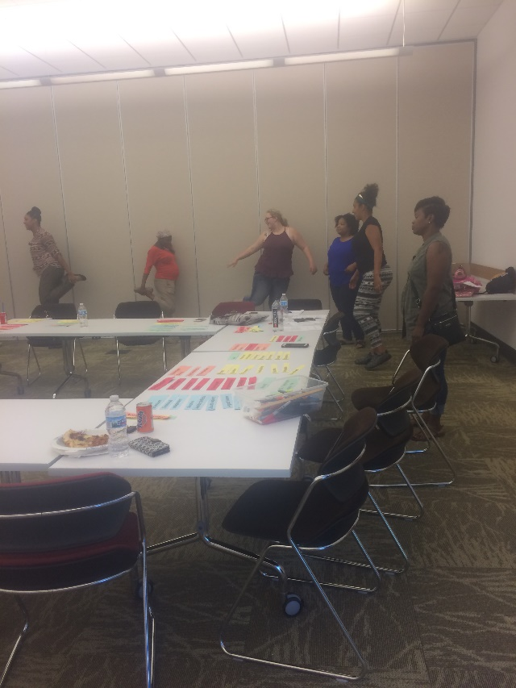

Standing Stretches
Neck Stretches
- Side-to-Side: Slowly move your head to the left and hold for 5 seconds. Then move to the right and hold for 5 seconds. Repeat 5 times. If you need a better stretch, use your hands to turn your head even further to the side. | 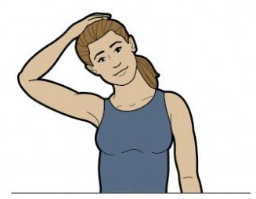
- U-Stretch: Move your head to the right side (move your right ear towards your right shoulder), and then move your head to the to the middle (so that your chin is near your chest), then to the left side. Repeat 5 times. | 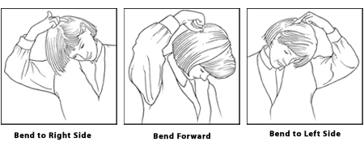
Arms
- Arm Circles: Open your arms wide and start making small circles clock-wise and gradually get bigger. Do this for 20 to 30 seconds. Then do counter-clockwise. | 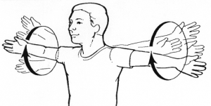
- Shoulder stretch: Place one arm across your body, keeping it parallel to the ground. Slowly pull your elbow towards your body. Hold this stretch for 20 seconds and switch sides. | 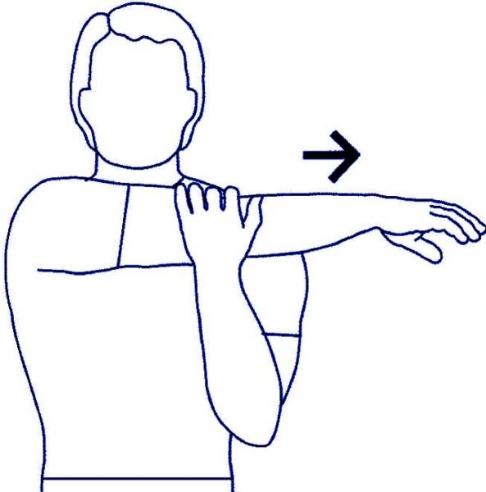
- Tricep stretch: Bring your arms up, then bend your arm so that your right hand is touching the back of your neck. With the other hand, bring your elbow towards your head. Hold this stretch for 20 seconds and switch sides. | 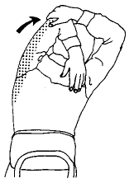
Waist stretch
- Side Abs Stretch: Interlace your fingers and bring it above your head with your arms straight. Then move the top part of your body (do not move your hips) to the right side. Hold this stretch for 5 seconds, and repeat on the other side. Repeat this stretch 3 times. | 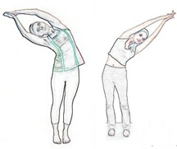
- Waist circles: Stand with your legs shoulder-width apart. Put your arms on your hips and move your hips in circles. Do this for 20 seconds, then move your hips in opposite circles. | 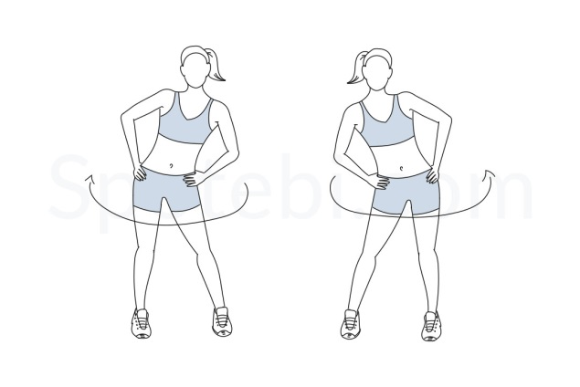
Legs
Quad Stretch: Balance on your left leg, and bring your right leg back and hold with your right hand. Hold this stretch for 20 seconds, and repeat on the other side. | 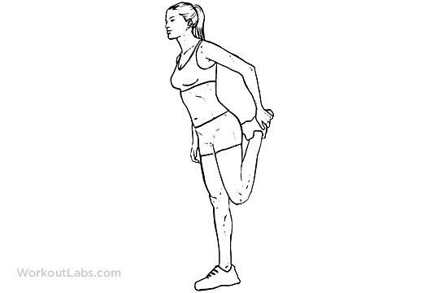
Inner thigh stretch: Stand with your legs as wide as your arms stretch, bend down and reach both hands to your right foot. Hold this stretch for 20 seconds, and repeat on the other side. | 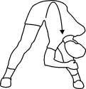
Tipover Tuck Hamstring Stretch: Stand with your feet hips-width distance apart. Interlace your hands behind your back. Keeping your legs straight, bend at the hips, tucking your chin and bringing your hands over your head. Hold this stretch for 30 seconds. | 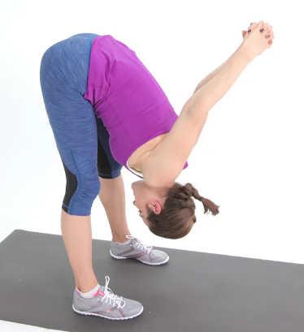
Hamstring stretch: Bring your feet together so that they are touching. Then bend forward and try to touch the floor. Hold this stretch for 30 seconds. | 
Feet circles: Bring your right leg forward in the air and move only your feet in circles 15 times. Do reverse circles 15 times. Repeat on the left leg. | 