Quick Reference Guide
Clear Cache Instructions for Chrome
- Open Chrome.
- In the top right corner, click this icon:
- Select the Settings option from the menu.
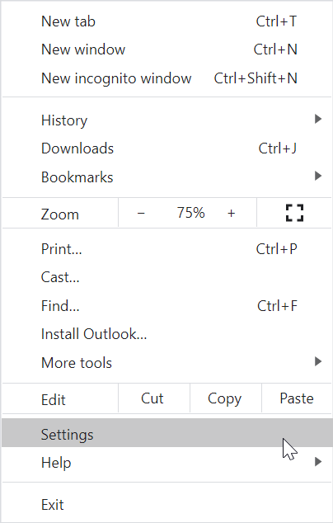
- From the Settings screen, select the Clear Browsing Data.
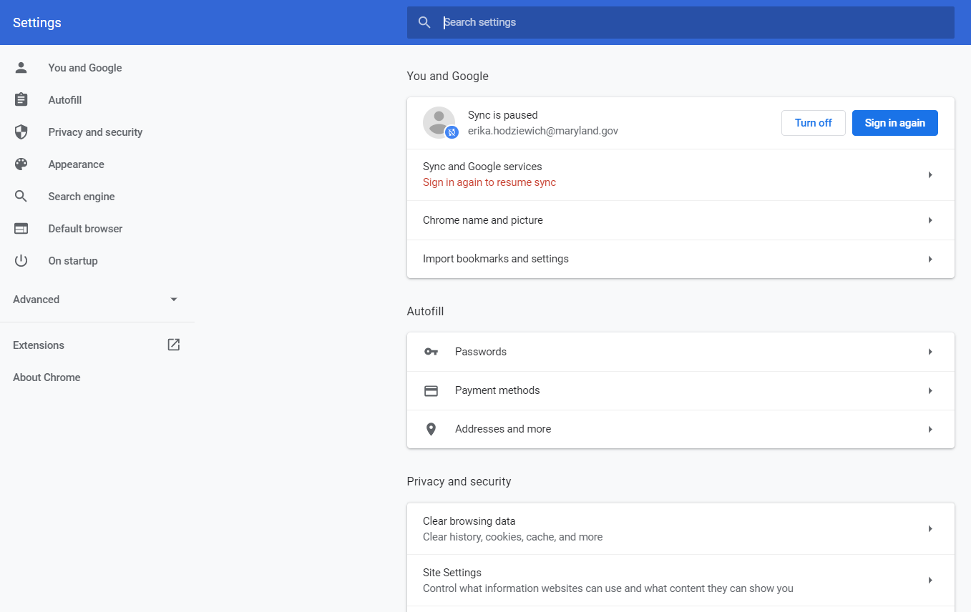
- Select the Clear Data button.
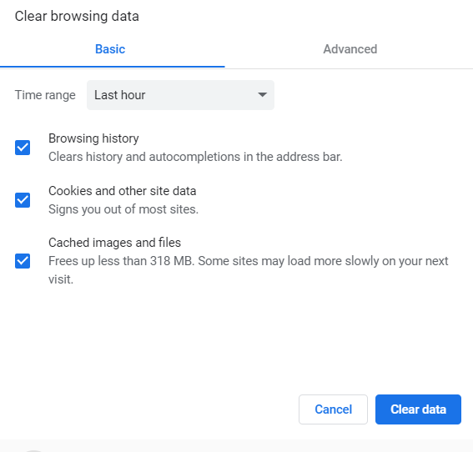

Clear Cache Instructions for IE
- Open IE.
- In the top right corner, click this icon:
- Select Internet Options from the menu.
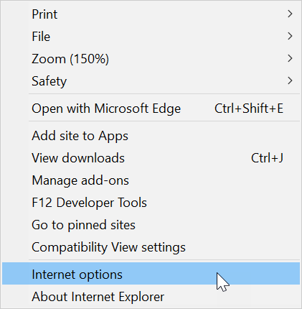

- Select the Delete button within the Browsing History section on the Internet Options pop-up.
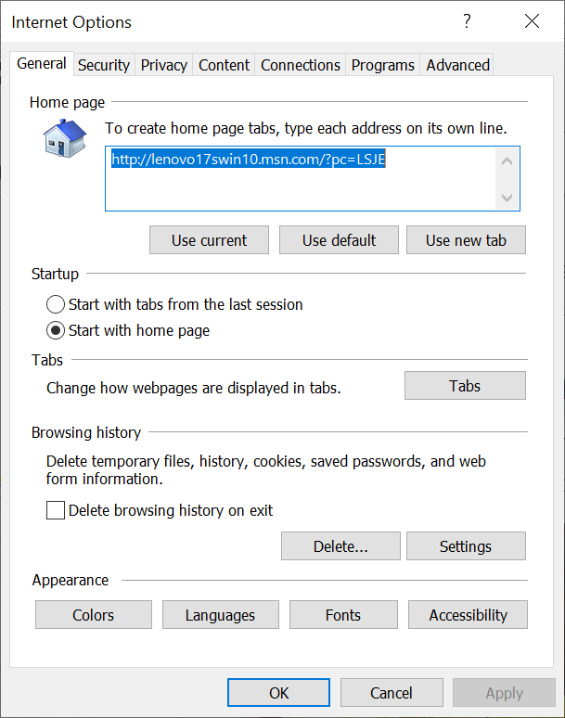

- From the Delete Browsing History pop-up, select the Delete button.
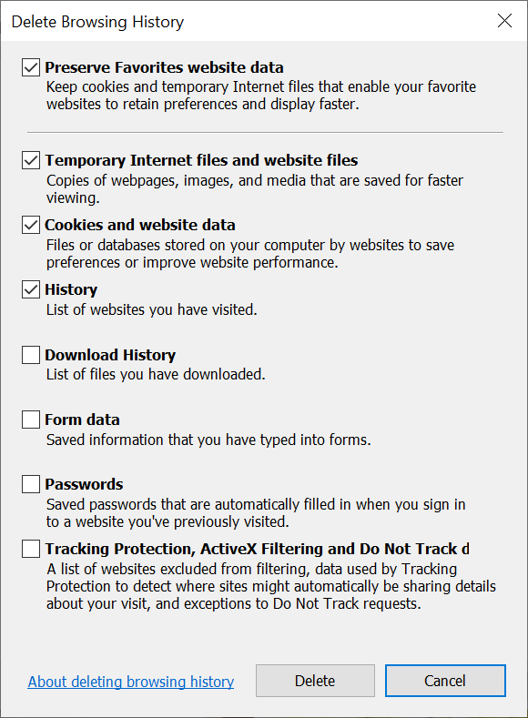

- To close the Internet Options pop-up, click the Ok button.
